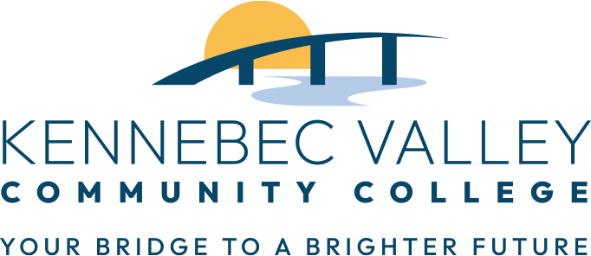

Job Title: Athletic Marketing Student Assistant
Supervisor: Director of Communications and Marketing & Athletic Director
Pay Rate: $14.65/hour
Schedule: Up to 20 hours per week
Academic Year: 2025-26
Interested candidates should email Elizabeth Belle Isle at ebelleisle@mainecc.edu
JOB DESCRIPTION:
The Athletic Marketing Student Assistant will play a key role in supporting the marketing and promotional efforts of the college’s athletic programs. This position is designed for students interested in gaining experience in sports marketing, event operations, and digital media.
QUALIFICATIONS/SKILLS:
  - Currently enrolled student at Kennebec Valley Community College
  - Interest in sports, marketing, promotions, or event management
  - Energetic, dependable, and detail-oriented
  - Comfortable interacting with students, fans, and external audiences
  - Flexible hours, including evenings, weekends, and some holidays
  - Basic knowledge of social media platforms (Instagram, Twitter/X, TikTok)
  - Experience in customer service, sports event operations, or student leadership
  - Familiarity with graphic design tools (Canva, Adobe, etc.)
  - Photography or video editing skills
  - Learn and manage Presto Software among other programs (Sideline, Word Press, etc.)
RESPONSIBILITIES:
- Game Day Management (stats, officials, coaches, laundry, support as assigned)
- Create social media content and assist with platform engagement (stories, reels)
- Assist with the creation and execution of in-game promotions and fan engagement
- Contribute to game day setup and breakdown (signage, promo tables, giveaways)
- Promote athletic events through tabling, poster distribution and social media
- Operate music, microphones during events (as needed)
- Support marketing and athletics with student contests and community outreach
- General office tasks, organizing supplies, tracking participation and social media effectiveness
- Represent the Athletic Department professionally to fans, students, and alumni

