2021 Intern – Summer Opportunity
Newport Industrial Fabrication continues to fabricate unique structures that require computer controlled equipment, three dimensional modeling software and coordinate based layout. This work creates a need for engineering support above and beyond the industry standard. Summer activities will include developing and trialing CNC plasma operations, 3D modeling, supporting project team functions and learning about engineering in the steel industry.
An intern will have plenty to learn while simultaneously supplying NIF with additional capacity to extend our engineering offerings. This is potentially the precursor to adding an additional permanent engineer.
Interested candidates should fill out an application for employment available at www.nif-inc.com
Please include with a resume and any other supporting documents emailed to Dan - Dan@nif-inc.com
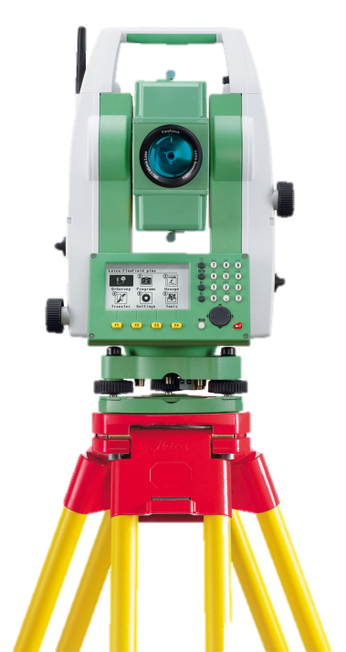
Project Examples:
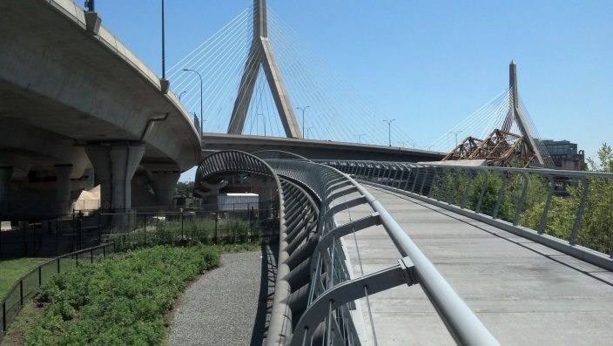  Sinusoidal Pedestrian Bridge  http://bit.ly/NorthBank-NIF | 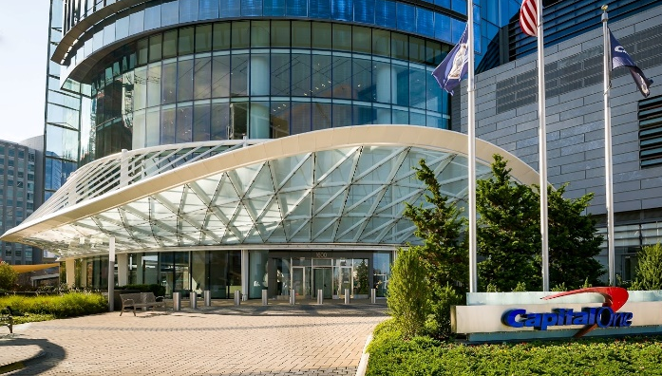  Capital One Headquarters Canopy  http://bit.ly/Cap1-Canopy-NIF
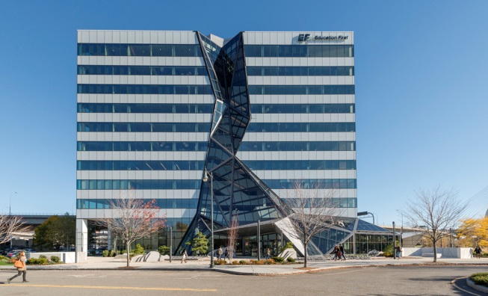  EF Glass Waterfall  http://bit.ly/EFWaterfall-NIF | 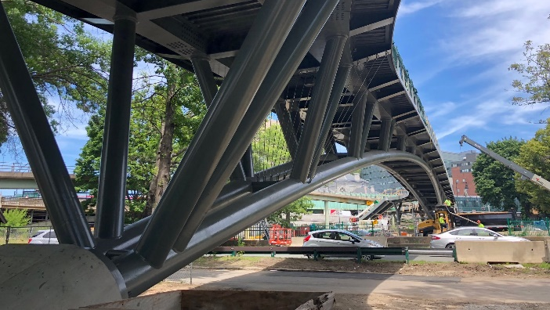  Boston Pedestrian Bridge  http://bit.ly/longfellow-nif

