POSITION DESCRIPTION
 |  | 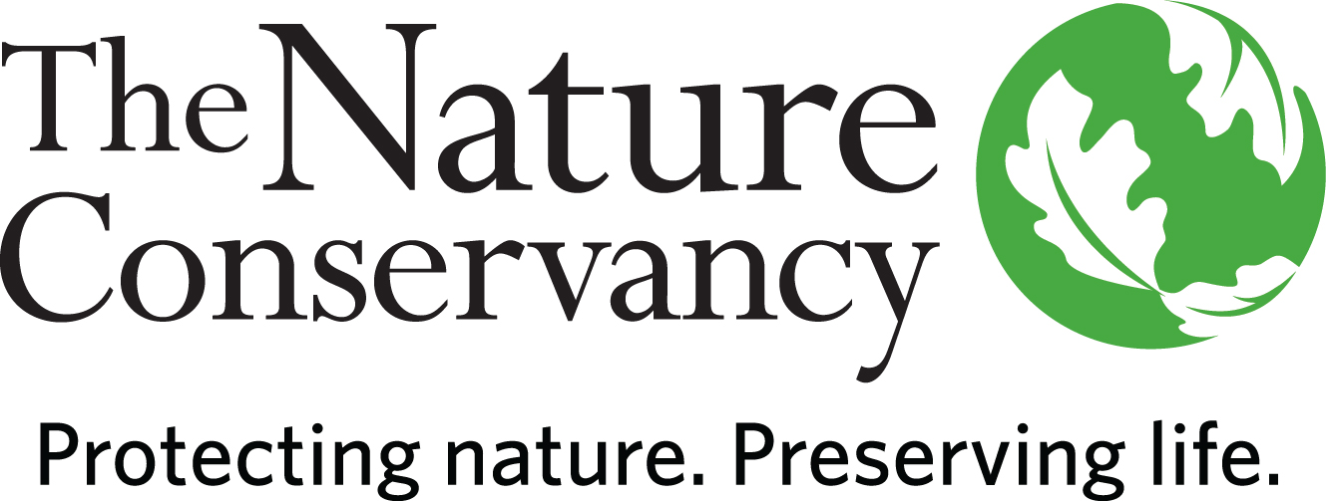
POSITION TITLE | Development Coordinator
JOB FAMILY | Development
JOB NUMBER | 570006
SALARY GRADE | 4
STATUS | Hourly
DATE | April 2021
A LITTLE ABOUT US

Since 1951, The Nature Conservancy has been doing work you can believe in protecting the lands and waters that all life depends on. As a science-based organization, we create innovative, on-the-ground solutions to our world’s toughest challenges so that we can create a world in which people and nature thrive.
The Maine Chapter is The Nature Conservancy's fourth oldest chapter, founded in 1956 by Rachel Carson and other leading Maine citizens concerned about the loss of wildlife habitat. More than 8,000 families, foundations and corporations have helped the Maine Chapter protect over 1,000,000 acres of Maine's most important lands. The Conservancy owns and manages some 290,000 acres in Maine, including the largest system of nature preserves in the state.
We’re rooted in our Mission and guided by our Values, which includes a Commitment to Diversity and Respect for People, Communities, and Cultures. We know we’ll only achieve our Mission by hiring and engaging a diverse workforce that reflects the communities in which we work. Whether it’s career development, work/life balance, or a rewarding mission, there’s lots of reasons to love life #insideTNC. Our goal is to cultivate an inclusive work environment so that all of our colleagues around the globe feel a sense of belonging, and that their unique contributions to our mission are valued.

To learn more, visit www.nature.org/maine or follow @nature_press on Twitter.

YOUR POSITION WITH TNC

The Development Coordinator works on a variety of activities in support of The Nature Conservancy in Maine’s fundraising and donor stewardship activities. They are primarily responsible for recording gifts and pledges in the database, ensuring accuracy and donor intent, sending thank you letters, and tracking against a variety of metrics and goals. Additionally, they manage annual thank you call programs that help us celebrate and connect with our donors and engage staff and trustees in donor stewardship. Finally, they provide general administrative support to the Development team and assist with other fundraising projects as needed.

ESSENTIAL FUNCTIONS

The Development Coordinator works with colleagues within the chapter and across the organization to ensure gifts and pledges are accurately recorded to reflect donor intent and promptly acknowledged. They process donations, pledges and in-kind gifts for the Maine chapter, and they revise and send acknowledgment letters, pledge reminders, and internal forms. The Development Coordinator is responsible for ensuring all gifts have documentation which is properly filed in the donor record. They review grant award documentation to ensure appropriate approvals before gift acceptance. They are responsible for updating electronic donor records in the Conservancy’s fundraising database and will extract and analyze fundraising progress reports for development staff. They also facilitate the pledge review and fulfillment process in partnership with the finance manager. They assist the Development team in entering donor interactions into the database, scheduling meetings, and filing expense reports, along with other tasks as needed. The Development Coordinator runs the annual donor thank you call programs to steward our planned giving donors, new members, and monthly supporters. This position works with trustees and other chapter staff to recruit callers and provide training, scripts, and tracking of the thank you call programs.

RESPONSIBILITIES & SCOPE

- Responsible for processing contributions, sending acknowledgements/pledge reminders, and managing/filing gift documentation.
- Manages coding of all gifts, pledges, and non-exchange transaction revenue generated by the Chapter to ensure compliance with donor intent and FASB rules.
- Creates and maintains financial management and project reports for Director of Development.
- Tracks matching gifts and pledges to ensure accuracy and proper fund disbursement.
- Reviews grant agreements and award letters for legal compliance and risk avoidance; communicates to development team and finance manager.
- Responsible for preparing, revising, and tracking donor correspondence, such as pledge reminders and thank you letters.
- Ensures all donor correspondence and pledge/gift forms are compliant to Conservancy standards.
- Works with finance manager to ensure an internal audit with no findings for development.
- Provides administrative support to the Development team by updating donor records and other data entry needs, processing donor contact material, making travel arrangements, fielding phone calls from donors, setting up meetings, filing expense reports, and additional administrative tasks, as needed.
- Coordinates annual donor thank you call programs for new members, monthly donors and Legacy Club (planned giving) donors, supporting trustees and chapter staff while providing exemplary donor stewardship.
- Assists with other development team efforts, including event prep, large mailings, and annual planning.
- Assists with other departmental projects as assigned.

MINIMUM QUALIFICATIONS

- Bachelor’s degree and minimum 1 year of experience or equivalent experience.
- Experience in business writing, editing and proofreading.
- Experience managing diverse activities to meet deadlines
- Experience working and communicating with a wide range of people.
- Strong organizational skills and attention to detail required.
- Ability to analyze information for the purpose of preparing reports, coordinating projects, and solving problems.

DESIRED QUALIFICATIONS

- Multi-lingual skills and multi-cultural or cross-cultural experience appreciated.
- Database skills, including managing data and tracking prospects.
- Willingness & ability to develop and apply computer & research skills on an ongoing basis.
- Solid knowledge of word processing, data entry and spreadsheet software, with ability to use mail merges and some advanced functions.
- Basic understanding of fundraising principles & practices in a non-profit environment.
- Impeccable discretion and ability to maintain confidentiality.

ORGANIZATIONAL COMPETENCIES

Builds Relationships | Builds productive relationships by interacting with others in ways that enhance mutual trust and commitment.
Collaboration & Teamwork | Works collaboratively with stakeholders across levels, geographies, backgrounds, and cultures to improve decisions, strengthen commitment, and be more effective.
Communicates Authentically | Communicates proactively and in a timely manner to share information, persuade, and influence with the appropriate level of detail, tone, and opportunities for feedback.
Develops  Others | Takes ownership to help develop others’ skills, behaviors, and mindsets to help them maximize their workplace contributions.
Leverages Difference | Demonstrates commitment to harnessing the power of differences strategically. consistently sees, learns from, and takes strategic action related to difference. and demonstrates the self-awareness and behaviors to work across differences of identity and power respectfully and effectively with all stakeholder. Actively seeks to build and retain a diverse workforce and fosters an equitable inclusive workplace by drawing upon diverse perspectives.
Systems  Leadership | Thinks and acts from a broad perspective with a long-term view and an understanding of 1) the dynamic nature of large-scale challenges and 2) the need for integrating five key practices: skillfully engaging appropriate people. providing a clear process for change. taking a holistic view of situations. focusing on a small number of strategic actions, while learning from and adapting them over time. and being aware of how one’s own thinking or patterns of behavior may be limiting change.

This description is not designed to be a complete list of all duties and responsibilities required for this job.

SALARY RANGE
Salary Range: $42,000-$47,000

