CAREER OPPORTUNITY
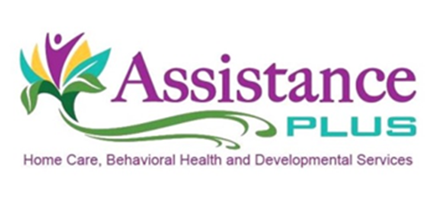
Training Coordinator

Assistance Plus is a social service and medical agency with offices in Benton, Brunswick, Waterville and Wilton, Maine. We provide long-term home health care, developmental disabilities and behavioral health services.

Assistance Plus is looking to hire a Training Coordinator part-time (24 hrs/3 days a week). As the Training Coordinator, you will be the key to keeping our staff currently trained in all required certifications needed to provide exemplary skills to our clients. Your expertise will include delivery, over-site and tracking of all required behavioral health and intellectual disabilities trainings to assure timely delivery of all mandatory trainings. The training programs include, CPR, MHSS, DSP, and Mandt (or other approved Crisis Intervention Training).

Requirements:
- Must have a minimum of an Associate’s Degree in a Human Services field;
- Two years of relevant work experience;
- Certificate showing completion of the MHSS course;
- Documentation of two years of recent experience training adult learners;
- Intermediate skill level in Microsoft Word and Excel;
- High school diploma or GED is required.
- Must be 18 years of age or older.
- Must have a valid State of Maine driver's license and automobile insurance coverage of $50k/$100k;
- Pass a comprehensive background check that includes criminal, motor vehicle, Child and Adult Protective Services.

Assistance Plus is an EEO/AA Employer. All qualified applicants will receive consideration for employment without regard to race, color, religion, sex, sexual orientation, gender identity or national origin.

Contact Information
Annette McLaggan, Recruiter
Human Resources
207-453-4708 x 306
How to apply: On line- assistanceplus.com/careers/

Assistance Plus
Home Care and Behavioral Health Agency
11 East Street, Benton, Maine 04937
207-453-4708

