CAREER OPPORTUNITY
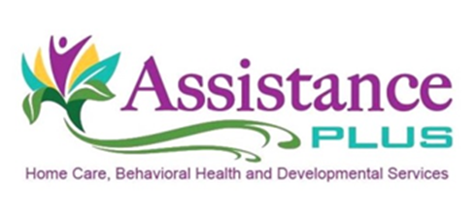
Personal Support Specialist/Caregiver

Assistance Plus has immediate part-time openings (working up to 40 hours per week) in our home health care department. Our caring, and compassionate Personal Support Specialists (PSS) assist our clients with personal care and activities of daily living while remaining in the comfort of their own homes. PSS's will commute to their clients homes.

Qualifications:
- No previous home health experience is needed.
- PSS certification and experience are preferred, but not required.
- Will train qualifying candidates
- Assistance Plus offers an on-line training course for all uncertified employees.

Requirements:
- Must have a high school diploma or GED,
- Reliable transportation,
- Auto liability insurance $50k/$100k coverage,
- A valid Maine driver's license.

Assistance Plus is an EEO/AA Employer. All qualified applicants will receive consideration for employment without regard to race, color, religion, sex, sexual orientation, gender identity or national origin.

Assistance Plus offers:
Competitive Wages, Paid Trainings, Mileage Reimbursement and Paid Travel Time, Earned Benefit Time, Flexible Work Schedules, Voluntary Insurances, Health and Dental Insurance, and a Supportive Team Environment
Our Mission
By supporting and caring for people at all points in life, together we can make a difference!

Contact Information
Annette McLaggan, Recruiter
207-453-4708 x 306

How to apply: Online at www.assistanceplus.com/careers/

Assistance Plus
Home Care and Behavioral Health Agency
11 East Street, Benton, Maine 04937
207-453-4708

