CAREER OPPORTUNITY
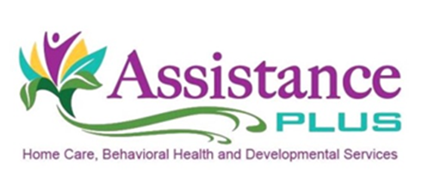
In-Home Therapist

*There is a $2000 bonus for eligible candidates, full-time, or $1,000 for part-time

Assistance Plus is a licensed homecare and behavioral healthcare organization. Our company provides a wide range of medical, behavioral and intellectual disability services for children, adolescents, adults and elderly in-home and in their communities.

Presently, we have an opportunity for a full-time or part-time Therapist providing In-Home Therapy services. This position will be based out of our main office in Benton, Maine.
The In-Home Therapist is responsible for providing assessments, counseling, and therapeutic services with the targeted goal of reducing excessive stress and providing positive orientations and growth toward integrated and independent functioning. The therapist is responsible for assuring that services are being delivered using psychosocial, psychological, and sociological concepts, techniques, and process of evaluation and intervention.
**Candidates must be flexible, motivated and team-oriented.

Requirements:
- LCSW, LMSW-CC, LCPC, LCPC-C, LMFT, LMFT-C, or Licensed Clinical Psychologist
- Master's Degree
- Valid Maine driver’s license
- Must be 18 years of age or older
- A minimum of two years of experience working with children and adults with behavioral health diagnoses.
- Knowledge of psychotropic medications
- Reliable transportation, $50K/$100K liability insurance, Maine driver’s license
*Competitive Rates of Pay*, Earned Benefit Time, Flexible schedule, Health, Dental and voluntary benefits

Assistance Plus is an EEO/AA Employer. All interested individuals are directed to visit our website at www.assistanceplus.com to complete an application.

Contact Information
Annette McLaggan, Recruiter
Human Resources
207-453-4708 x 306
How to apply: Online at www.assistanceplus.com/careers/

Assistance Plus
11 East Street, Benton, Maine 04937
207-453-4708

