CAREER OPPORTUNITY
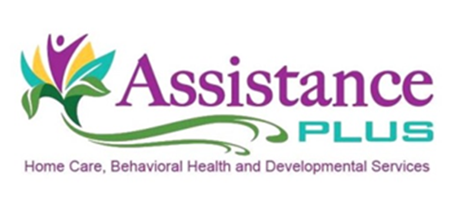
Home Healthcare Registered Nurse (RN) Multiple positions

Assistance Plus has an immediate opening for multiple part-time RNs to join our team! The RN will provide weekly in-home visits and nursing assessments to our clients. Positions available in the Brunswick, Skowhegan and Lewiston areas.

Requirements:
- The RN is required to hold a valid Maine Nursing License,
- Be in good standing with the Board of Nursing,
- 1 year of Med/Surg. experience,
- Valid Maine Drivers' License,
- $50K/$100K automobile insurance,
- Reliable transportation and
- Have a current CPR/1st Aid certification.
All job offers are contingent on successful results of credential verification, criminal history, references, DHHS and driver's license background checks along with verification of professional license requirements if applicable.
Assistance Plus is an EEO/AA Employer. All qualified applicants will receive consideration for employment without regard to race, color, religion, sex, sexual orientation, gender identity or national origin.
Assistance Plus offers:
Competitive Wages, Paid Trainings, Mileage reimbursement and paid travel time, Earned Benefit Time, AAA Discounts, Voluntary Insurances, Health and Dental Insurance, Flexible Work Schedules, and Supportive Team Environment
Contact Information
Annette McLaggan, Recruiter
207-453-4708 x 306
How to apply: Online at www.assistanceplus.com/careers/

Assistance Plus
Home Care and Behavioral Health Agency
11 East Street, Benton, Maine 04937
207-453-4708

