CAREER OPPORTUNITY
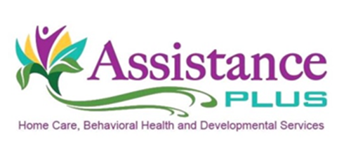
Direct Support Professional

Assistance Plus has openings for part-time (working up to 40 hours per week) Adult Direct Support Professionals (DSP) to join our team. They will provide in-home and community support to adults with cognitive disabilities according to the clients’ individual treatment plan.

Applicants must have:
- High school diploma or GED
- DSP certification preferred, but will train qualifying candidates
- Employees are required to have a valid Maine driver's license, reliable transportation and $50K/$100K automobile liability insurance as they will commute to their clients’ homes and transport to community activities as needed

Assistance Plus is an EEO/AA Employer. All qualified applicants will receive consideration for employment without regard to race, color, religion, sex, sexual orientation, gender identity or national origin.

Our Mission
By supporting and caring for people at all points in life, together we can make a difference!

Assistance Plus offers:
- Competitive Wages
- Paid Trainings
- Mileage reimbursement and paid travel time
- Earned Benefit Time
- AAA Discounts
- Voluntary Insurances
- Health and Dental Insurance
- Flexible Work Schedules
- Supportive Team Environment
Contact Information
Annette McLaggan, Recruiter
Human Resources
207-453-4708 x 306
How to apply: Online at www.assistanceplus.com/careers/

Assistance Plus
Home Care and Behavioral Health Agency
11 East Street, Benton, Maine 04937
207-453-4708

