CAREER OPPORTUNITY
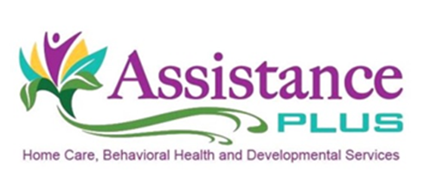

Daily Living Support Specialist/In-Home Behavioral Health Worker

Assistance Plus is currently seeking a part-time Daily Living Support Specialist to carry out services that focus on the specific needs of clients with Mental Health diagnoses. The MHRT-1 will assist clients in their homes and surrounding communities to promote independence. MHRT-1’s will commute to their clients homes and transport their clients to community activities.

Hours are flexible and pay starts between $12-$14 per hour

Qualifications:
- Must have a high school diploma or GED;
- Hold a valid Maine Driver's license;
- Have reliable transportation, and
- $50K/$100K automobile liability insurance;
- MHRT-1 preferred, but will train the ideal candidate

Assistance Plus is an EEO/AA Employer. All qualified applicants will receive consideration for employment without regard to race, color, religion, sex, sexual orientation, gender identity or national origin. EEO/AA Employer

Assistance Plus offers:
Competitive Wages, Paid Trainings, Flexible Work Schedules, Mileage reimbursement and paid travel time, Earned Benefit Time, Voluntary Insurances, Health and Dental Insurance and a Supportive Team Environment

Agency Profile
Assistance Plus is dedicated to improving the quality of life of those around them,
through upholding respect, dignity and confidentiality for all those served. Our caring
professionals advocate and coordinate services for families in need of supportive home
care or behavioral health services.

Contact Information
Annette McLaggan, Recruiter
Human Resources, 207-453-4708 x 306
How to apply: Online at www.assistanceplus.com/careers/
Assistance Plus
11 East Street, Benton, Maine 04937
207-453-4708

