CAREER OPPORTUNITY
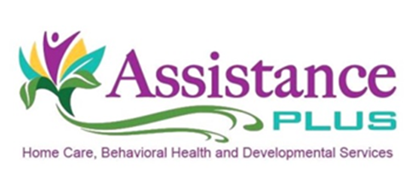
CHILDREN’S CASE MANAGER

Assistance Plus has an immediate opening for a full-time Children’s Case Manager covering Kennebec and Somerset Counties and the surrounding areas. The CCM will assist our clients with Mental Health diagnoses that reside in the community by assisting in the development of community resources, coping skills and natural supports. Responsibilities include identifying unmet needs, resolving barriers to needed services, and monitoring the client’s supports to ensure they match their individuals' needs.

- Candidates are required to have reliable transportation, $50K/$100K automobile liability insurance and a valid Maine driver's license, this is a travel position.

- Candidates are also required to have a Bachelor’s degree and must attain their Mandt, CPR, and First Aid trainings within 90 days of employment.

Assistance Plus is an EEO/AA Employer. All qualified applicants will receive consideration for employment without regard to race, color, religion, sex, sexual orientation, gender identity or national origin.

Assistance Plus offers:

- Competitive Wages
- Paid Trainings
- Mileage reimbursement and paid travel time
- Earned Benefit Time
- AAA Discounts
- Voluntary Insurances
- Health and Dental Insurance
- Flexible Work Schedules
- Work Laptop and Cell Phone
- Supportive Team Environment

Contact Information
Annette McLaggan, Recruiter
Human Resources
207-453-4708 x 306
Assistance Plus
Home Care and Behavioral Health Agency
11 East Street, Benton, Maine 04937
207-453-4708

