CAREER OPPORTUNITY
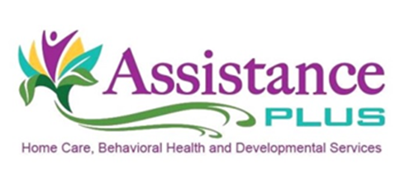
Adult Case Manager

Assistance Plus is a licensed homecare and behavioral healthcare organization. Our company
provides a wide range of medical, behavioral and intellectual disability services for children,
adolescents, adults and elderly in-home and in their communities.

Assistance Plus is seeking a highly responsible, compassionate, and motivated individual to join our team as a mental health Adult Case Manager. As an Adult Case Manager, you will work with consumers in their homes and surrounding communities by linking them to community resources, accessing services and providers, and managing their symptoms.

Job Duties Include:

- Assisting with housing needs
- Assisting with applying for insurance and food supplement benefits
- Developing consumer driven treatment plans that promote independence
- Connecting consumers to needed medical and mental health services

Assistance Plus offers:

- Competitive Wages
- Paid Trainings
- Mileage reimbursement and paid travel time
- Earned Benefit Time
- AAA Discounts
- Voluntary Insurances
- Health and Dental Insurance
- Flexible Work Schedules
- Work Laptop and Cell Phone
- Supportive Team Environment

Assistance Plus
Home Care and Behavioral Health Agency
11 East Street, Benton, Maine 04937
207-453-4708

Adult Case Manager

Qualifications Required:

- MHRT-C or MHRT-C provisional
- The ability to work independently and as a team with a high level of professionalism
- Minimum of three years relevant work or life experience
- Must be 18 years or older and have High school diploma or GED
- Must hold a valid Maine Driver’s license, have reliable transportation, and $50K/$100K automobile liability insurance coverage
- Assistance Plus is an EEO/AA Employer. All qualified applicants will receive consideration for employment without regard to race, color, religion, sex, sexual orientation, gender identity or national origin.
- Comprehensive background check
- Entry level computer experience

Our Mission

By supporting and caring for people at all points in life, together we can make a difference!

Agency Profile

Assistance Plus is dedicated to improving the quality of life of those around them, through
upholding respect, dignity and confidentiality for all those served. Our caring professionals
advocate and coordinate services for families in need of supportive home care or behavioral health
services.

Contact Information

Annette McLaggan, Recruiter
Human Resources
207-453-4708 x 306

How to apply: Online at www.assistanceplus.com/careers/

Assistance Plus
11 East Street, Benton, Maine 04937
207-453-4708

